Quality Manual
In support of ISO 9001:2015

Table of Contents
1 Introduction 4
2 References 4
3 Definitions 4
4 About Our Organisation 5
4.1 Organizational Context 5
4.2 Relevant Interested Parties 6
4.3 Quality Management System 6
4.3.1 Management System Scope 6
4.3.2 Management System Processes 6
4.3.3 Outsourced Processes 7
4.3.4 Documented Information 7
5 Leadership & Governance 8
5.1 Leadership & Commitment 8
5.1.1 Quality Management 8
5.1.3 Quality Policy 9
5.2 Role, Responsibilities & Authorities 10
5.3 Communication 11
5.3.1 Internal Communication 11
5.3.2 External Communication 11
6 Management System Planning 12
6.1 Addressing Risks & Opportunities 12
6.2 Quality Objectives 13
6.3 Planning for Change 13
7 Support 14
7.1 Resources 14
7.1.1 General 14
7.1.2 People 14
7.1.2 Infrastructure 15
7.1.4 Operational Environment 15
7.1.5 Monitoring & Measurement Tools 15
7.1.6 Organisational Knowledge 16
8 Product & Service Development 16
8.1 Operational Planning & Control 16
8.2 Customer Requirements 17
8.2.1 Customer Communication 17
8.2.2 Determining Requirements 17
8.2.3 Review of Requirements 17
8.2.4 Changes in Requirements 18
8.3 Design & Development 18
8.4 Control of Suppliers & External Processes 18
8.4.1 General 18
8.4.2 Purchasing Controls 19
8.4.3 Purchasing Information 19
8.5 Production & Service Provision _____________________________________________________ 19
8.5.1 Control of Production & Service Provision 19
8.5.2 Identification & Traceability 20
8.5.3 3rd Party Property 20
8.5.4 Preservation 20
8.5.5 Post-Delivery Activities 20
8.5.6 Control of Changes 20
8.6 Release of Products & Services 21
8.7 Control of Non-conforming Outputs 21
9 Performance Evaluation 21
9.1.1 General 21
9.1.2 Customer Satisfaction 22
9.1.3 Analysis and Evaluation 22
9.2 Internal Audit 22
9.3 Management Review 23
9.3.1 General 23
9.3.2 Inputs 23
9.3.3 Outputs 23
10 Improvement 24
10.1 General 24
10.1 Non-conformity & Corrective Action 24
10.2 Improvement 25
Appendices 26
A.1 Correlation Matrix 26
A.2 Interaction of processes ________________________________________________________ 28
A.3 Organization Chart 32

1 Introduction
Testmetric has developed and implemented a quality management system (QMS), which uses ISO 9001:2015 as a framework that allows our organization to document and improve our practices in order to better satisfy the needs and expectations of our customers, stakeholders and interested parties.
This manual describes the quality management system, delineates authorities, inter relationships and responsibilities of personnel operating within the management system. The manual also provides references to procedures and activities that also comprise our quality management system.
The manual is used to familiarise customers and other external organizations or individuals with the controls that have been implemented and to assure them that the integrity of our quality management system is maintained and is focused on customer satisfaction and continual improvement.
Our quality management system meets the requirements of ISO 9001:2015 and uses the Plan, Do, Check and Act approach to process planning. Our QMS addresses and supports our strategies for the Testmetric provides:
Sales, Calibration & Repair Services of Test & Measurement Equipment since 2004. Industries served include Manufacturing, Pharmaceutical, Aerospace, Military, Educational and Utility Field.
The Facility is located as follow:
Testmetric
605C Cité des Jeunes,
St-Lazare, Qc, J7T 2A7
Tel: 1-877-424-7717 Fax: 450-424-7717
Email: sales@testmetric.com
www.Testmetric.com

The following table identifies any ISO 9001:2015 requirements, from Section 8.0, that are not applicable to our organization as well as providing a brief narrative to justify their omission from the scope of our QMS:
Clause | Justification for Exclusion
8.3 | We exclude design and development from our QMS, as we do not design or modify components

2 References
In addition to ISO 9001:2015 we also make reference to other relevant international standards as well as customer specifications appropriate to our products and market.
Standard | Title | Description
ISO 9000:2015 | Quality management systems | Fundamentals and vocabulary
ISO 9004:2018 | Quality management systems | Guidelines for performance improvements
ISO 19011:2018 | Auditing management systems | Guidelines for auditing

3 Definitions
This document does not introduce any new definitions but rather relies on the following:
- Definitions typically used by our customers, stakeholders or marketplace;
- Terms typically used in standards and regulations as they relate to our QMS or products;
- Standard business terminology;
- Terms and vocabulary commonly used in quality and Calibration practices.
- About Our Organisation

4.1 Organizational Context
Testmetric is committed to defining our position in the marketplace and understanding how relevant factors arising from legal, political, economic, social and technological issues influence our strategic direction and our organizational context.
Figure 1: Typical QMS Input Hierarchy
Local Factors
Macro Environment
External Issues
Interested Parties
Internal Issues
Testmetric identifies, analyzes, monitors and reviews factors that may affect our ability to satisfy our customers and stakeholders, as well as factors that may adversely affect the stability of our process, or our management system’s integrity.
To ensure that our QMS is aligned with our strategy, whilst taking account of relevant internal and external factors; we initially collate and analyze pertinent information in order to determine potential impact on our context and subsequent business strategy.
Testmetric then monitors and reviews this information to ensure that a continual understanding of each group’s requirements is derived and maintained. To facilitate the understanding of our context, we regularly consider issues that influence our context during management review meetings and are conveyed via minutes and business planning documents.
Internal Issues | External Issues
Market share | Customers & suppliers
Employees | Markets & competition
Performance | Regulatory & statutory
Values & culture | Technological
Innovation & knowledge | Cultural & social

The output from this activity is evident as an input to the consideration of risks and opportunities, and the actions that we take to address them. Refer to Section 6.1 for more information about our risk and opportunity management framework.
Although we acknowledge that ISO 9001:2015 does not require our organizational context to be maintained as documented information, we maintain and retain, in addition to this document, the following documented information to describe our organizational context:
- Context of the organization Data (R 612);
- SWOT analysis reports or schedules for internal issues (R 613);
- Minutes of meetings (Management Review minutes F 930), process maps and reports, etc.
SWOT analysis provides our organization with a framework for reviewing and evaluating our strategies, and the position and direction of our organization, business propositions and other ideas. Similarly PESTLE analysis provides our organization with framework for measuring our market and growth potential according to external political, economic, social, technological, legal and environmental factors.

4.2 Relevant Interested Parties
Testmetric recognizes that we have a unique set of interested parties whose needs and expectations change and develop over time, and furthermore; that only a limited set of their respective needs and expectations are applicable to our operations or to our quality management system. Such needs and expectations broadly include those shown in the table below.
Interested Parties | Needs & Expectations
Customers | Price, reliability & value
Distributors & retailers | Quality, price & logistics
Owners | Profitability & growth
Employees | Shared values & security
Suppliers | Beneficial relationships
Regulatory & statutory | Compliance & reporting

To ensure that our products and processes continue to meet all relevant requirements, we identify and assess the potential impact of any relevant needs and expectations that may be elicited from the interested parties. Where appropriate, to ensure that our processes are aligned to deliver the requirements of our interested parties; we convert relevant needs and expectations into requirements which become inputs to our QMS and to our product and service designs.

4.3 Quality Management System

4.3.1 Management System Scope
Based on the analysis of the issues and requirements identified in Sections 4.1 and 4.2, Testmetric has established the scope of our quality management system in order the implement our objectives and our policies that are relevant to our context, products and any interested parties.
This document describes our quality management system, delineates authorities, inter-relationships and responsibilities of process owners and personnel that operate within the system. Although we recognize that ISO 9001:2015 does not require a quality manual, we have decided to retain and update our quality manual, as our employees, customers, suppliers and other stakeholders perceive it to add value to our operations.
This document also demonstrates the relationship between our quality management system and the sequence and interaction of our key processes. Conformance to ISO 9001:2015 has been verified utilizing a formal assessment and review process by SGS.

4.3.2 Management System Processes
Testmetric has implemented a quality management system that exists as part of a larger strategy that has established, documented and implemented our processes, quality policies and objectives, satisfying the requirements of ISO 9001:2015.

To achieve this, Testmetric has adopted the process approach advocated by ISO 9001:2015. Top management has determined the processes required for achieving the intended outputs. By defining four key process-groups and by managing their inputs, activities, controls, outputs and interfaces; we ensure that system effectiveness is established maintained. These key process groups include;
Figure 2 : Key Process Groups
- Leadership and planning processes;
- Customer and stakeholder processes;
- Product/service development processes;
- Evaluation and improvement processes.
These process groups are described using tools such as documented procedures, process maps, flow diagrams, matrices, schedules, and charts, etc. Refer to the Sequence & Interaction of Processes in Appendix A.2 which shows the sequence and interaction of the process groups within our management system.
It is recognized that defining, implementing and documenting our quality management system is only the first step towards fully implementing its requirements. The effectiveness of the each process and its subsequent output is measured and evaluated through regular internal audits, quality inspections and data analysis.
We use key performance indicators (KPIs) that are linked to our objectives to control and monitor our processes, as well as assessments to determine the risks and opportunities inherent to each process. We use trends and indicators relating to nonconformities, objectives and corrective action, as well as, monitoring and measurement results, audit results and customer satisfaction data, process performance and the conformity of our products.

4.3.30Outsourced Processes
Where Testmetric identifies the requirement to outsource any process, or part thereof, which affects conformity with the stated requirements; Testmetric identifies control criteria such as; the competence of personnel, inspection regimes, the provision of product conformity certificates, adherence to specifications and specific job files, etc. Refer to Section 8.4.
The controls identified do not absolve us of the responsibility to conform to client, statutory and regulatory requirements but instead they enhance our capacity to effectively manage our supply chain. The controls adopted are influenced by the potential impact of outsourcing on meeting customer or stakeholder requirements and the degree to which control of the process is shared. Outsourced processes are controlled via purchasing and contractual agreements. Refer to Section 8.4. They may also be assessed by 2nd party audits and performance data reviews where appropriate,

4.3.49Documented Information

4.3.4.1 Management System Documents
Testmetric ensures that our QMS includes the documented information that is required to be maintained and retained by ISO 9001:2015, and additionally, any documented information identified by our organization that demonstrates the effective operation of our QMS. Refer to the Register of Documented Information.
Testmetric applies the following criteria to all types of documented information in order to assess whether the information is necessary for demonstrating the effectiveness of our QMS, and whether it should be formally controlled.
- Communicates a message internally or externally;
- Provides evidence of process and product conformity;
- Provides evidence that planned outputs were achieved;
- Provides knowledge sharing.
Should any of the above criteria apply, Testmetric ensures that this information is retained and/or maintained as a form of 'documented information'

4.3.4.2 Creating & Updating
Testmetric ensures that when we create documented information it is appropriately identified and described (e.g. title, date, author, reference number) and is available in an appropriate format (e.g. language, software version, graphics, etc.) and on appropriate media (e.g. paper, electronic). All documented information is reviewed and approved for suitability and adequacy.

4.3.4.3 Controlling Documented Information
Documented information is retained to provide evidence of conformity to the requirements specified by ISO standards, customer requirements and of the effective operation of our management system. Testmetric uses standard forms and templates that are accessed via a local area network computer system. An electronic document management system, which is backed up and updated as required, is used to retain documented information ensuring only the current versions are available to users. All management system documents are controlled according to the Control of Documents Procedure ; it defines the process for:
- Approving documents for adequacy prior to issue;
- Reviewing and revising as necessary and re-approving documents;
- Ensuring that changes and current revision status of documents are identified;
- Ensuring that relevant versions of applicable documents are available at points of use;
- Ensuring that documents remain legible and readily identifiable;
- Ensuring that documents of external origin are identified and their distribution controlled;
- Preventing the unintended use of obsolete documents;
- Ensuring that documents of external origin are identified and their distribution controlled.
Supporting documentation:
P 751 Control of Documents
P 752 Control of Records

5 Leadership & Governance

5.1 Leadership & Commitment

5.1.1 Quality Management
Testmetric’s leadership is also responsible for implementing the QMS, which includes the development and deployment of the quality policy, the quality objectives, and product/project-specific plans that are customer focused.
Top management provides the leadership and governance to all activities related to the lifecycle processes including defining the strategic direction, responsibility, authority, and communication to assure the safe and effective performance.
Testmetric’s governance structure provides necessary support for creating and establishing appropriate processes that are important for maintaining and achieving our quality objectives and policies.
In addition, governance activities include systematic verification of the effectiveness our QMS by undertaking internal audits and analysing performance data.
Regular management reviews ensure that our quality management system is adequate and effective, and that any necessary adjustments are made as a result.
Top management is committed to implementing and developing the quality management system and this commitment is defined by our corporate policies and objectives. Testmetric ensures that our policies are understood, implemented and maintained throughout at all levels of the organization through printed distribution of our policy statements and through periodic management review of the policy statements and corporate level improvement objectives. Testmetric communicates our mission, vision, strategy, policies and processes to all employees in order to:
- Create and sustain shared values of fairness and ethical behavior;
- Establish a culture of trust and integrity;
- Encourage commitment to quality;
- Provide people with the required resources, training and authority to act with accountability;
- Inspire, encourage and recognize people’s contribution.
In addition, our policies, objectives and targets are communicated and deployed throughout the business via individual performance objectives which are established and discussed during employee performance reviews. Customer Focus.
5.1.2 Customer Focus
Testmetric strives to identify current and future customer needs, to meet their requirements and to exceed their expectations. Top management ensures that the focus on improving customer satisfaction is maintained by setting and reviewing objectives related to customer satisfaction at management review meetings.
Top management also ensures that customer requirements are understood and met. Customer requirements are understood, converted into internal requirements and communicated to appropriate personnel within the organization. Customer complaints and other customer feedback are continually monitored and measured to identify opportunities for improvement. We continually look for ways to interact directly with our customers to ensure that we focus on their unique needs and expectations.
    - Quality Policy
      - Establishing & Communicating
The quality policy acts as a compass by providing the direction and framework for establishing key corporate level performance measures, as well as related objectives and targets. Top management ensures that our corporate policies are established and documented, and that the policies are available to all interested parties via our website.
The Technical Manager has overall responsibility for defining, documenting, implementing and reviewing our quality policy in consultation with the management teams and other personnel, or their representatives. The policy is reviewed at least annually, as part of the management review programs or at a frequency determined by:
- The changing needs and expectations of relevant interested parties, Section 4.2.
- The risks and opportunities that are presented through the risk management process, Section 6.1.
The quality policy is communicated to all employees at all levels throughout our organization via training, regular internal communications and reinforcement during annual employee performance reviews. Employee understanding of our policies and objectives is determined during internal audits and other methods deemed appropriate.

      - Quality Policy Statement


QUALITY POLICY
- Testmetric is committed to Provide Quality Products and Services to Meet or Exceed Customer Expectations.
- Testmetric is committed to maintain and continually improve the effectiveness of the Quality Management System.
- Testmetric improves its quality management system on a continuous basis in order to ensure gains in the following areas:
- On Time Delivery
- Order Acceptance Rate
- Product Conformity.

Paul Brisson
Testmetric
President/Technical Manager 08-Sep-17

  - Role, Responsibilities & Authorities
Our organizational structure is defined in Appendix A.3. The organization chart shows the interrelation of personnel within Testmetric, whilst job descriptions define the responsibilities and authorities of each role. Job descriptions and the organizational structure are reviewed and approved by Top management for adequacy as determined by the changing needs and expectations of the interested parties identified in Section 4.2, and any risk and opportunities presented through the risk management process, Section 6.1.
Members of Top management are ultimately responsible for the quality of Testmetric’s products and services since they control the resources, systems and processes by which conforming work is accomplished. Top management are responsible for business planning, development and the communication of our policies, quality management system planning, the establishment and deployment of objectives, the provision of resources needed to implement and improve the quality management system and for undertaking management reviews. Top management has assigned the responsibility and authority to the management teams and departments to:
- Ensure that QMS processes are delivering their intended outcomes;
- Report on the operation of the QMS and identifying any opportunities;
- Ensure that improvement is taking place;
- Ensure that customer focus is promoted throughout the organization;
- Ensure that whenever changes to the QMS are planned and implemented;
- Ensure the integrity of the system is maintained during changes;
- Ensure that responsibilities and authorities relating to the QMS are communicated and understood.
All managers demonstrate their commitment to the development and improvement of the quality management system through the provision of necessary resources, through their involvement in the internal audit process and through their proactive involvement in continual improvement activities. Emphasis is placed on improving both the effectiveness and efficiency of key system processes.
All managers are responsible for execution of the business plan and the implementation of the policies, processes and systems described in this manual. All managers are responsible for planning and controlling the management system processes within their area of responsibility, including the establishment and deployment of operational level objectives and the provision of resources needed to implement and improve these processes.
All employees are responsible for the quality of their work and implementation of the policies and procedures applicable to processes they perform. Personnel responsible for product quality have the authority to stop production to correct quality problems. Employees are motivated and empowered to identify and report any known or potential problems and to recommend related solutions aid the corrective and preventive action process.
  - Communication

5.3.1 Internal Communication
Testmetric communicates information internally regarding our QMS and its effectiveness, through documented training, internal audit reports and continual improvement processes. All managers and supervisors are responsible for establishing regular formal and informal communications as needed to convey to their employees the relevance and importance of their activities; typically this information is conveyed through team meetings and cross-functional improvement projects.
Communications regarding how employees contribute to the achievement of objectives are also conveyed and reinforced during employee performance reviews. Issues pertaining to our QMS that may be communicated internally include:
- Day-to-day operations and general awareness;
- Quality policy;
- Information on achieving objectives and targets;
- Risk and opportunities.
Top management and their direct reports are responsible for communicating the corporate policies as well as the importance of meeting customer, statutory and regulatory requirements to employees within their respective departments. They ensure the quality policy is understood and applied to the daily work of the organization through the establishment of measureable goals and objectives. Internal communication occurs on an on-going basis and is achieved through various mechanisms as appropriate:
- Regular meetings and briefings;
- Training sessions and training material;
- Display boards, memorandums, letters;
- Website, intranet, internal e-mails;
- Product and process performance data analysis and audit results;
- Targets, objectives, scorecards, KPIs, management system manual and procedures;
- Corrective action and non-conformance reports;

5.3.2 External Communication
Testmetric determines the need to communicate information externally to our interested parties, as defined in Section 4.2, regarding the effectives of our QMS. In most instances, external interested parties (such as consumers, stockholders, neighboring communities, etc.) are the main driving force for our organization to implement our QMS. The various processes or means of external communication may include as appropriate:
Interested Parties | Needs & Expectations | Possible modes of Communication
Customers | Price, reliability & value | Publications in the media and focus groups
Distributors & retailers | Quality, price & logistics | Industry association publications and press releases
Owners/shareholders | Profitability & growth | Annual reports or newsletters of performance
Suppliers | Beneficial relationships | Publications on our website, meetings or questionnaires
Regulatory & statutory | Compliance & reporting | Regulatory compliance submissions or results of audits

- Management System Planning

6.1 Addressing Risks & Opportunities
The overall aim of risk and opportunity management within Testmetric is to ensure that organizational capabilities and resources are employed in an efficient and effective manner to take advantage of opportunities and to mitigate risks.
Figure 3: Risk & Opportunities PDCA Cycle
Top management are responsible for incorporating risk based thinking in to our organization's culture. This includes the establishment of risk management policies and targets to ensure effective implementation of risk and opportunity management principles and activities by:
- Providing sufficient resources to carry out risk and opportunity management activities;
- Assigning responsibilities and authorities for risk and opportunity management activities;
- Reviewing information and results from audits and risk and opportunity management activities.
The scope of Testmetric’s risk and opportunity management process includes the assessment of the internal and external issues identified in Section 4.1, and the assessment of the needs and expectations of any interested parties identified in Section 4.2. Risk and opportunity management is undertaken as part of Testmetric’s day-to-day operations and is captured at the following hierarchy: 1) Strategic level; 2) Programme level; 3) Department level; 4) Process level;
Establishing such a hierarchy for capturing risk and opportunity ensures that each is managed at the most appropriate level within our organization. Typically, the following categories are assigned to each level in the hierarchy as shown in the table opposite.
Business Hierarchy | Risk/Opportunity
Strategic level | Budgets and profitability
Programme level | Performance and efficiency
Department level | Resources and targets
Process level | Evaluation and assurance

Testmetric has classified its ‘risk appetite’ as the amount of risk that we are willing to accept in pursuit of an opportunity or the avoidance of risk where each pertains to product and/or system conformity, and which reflect the following considerations:
- Risk management philosophy per product or process;
- Capacity to take on or mitigate risk;
- Our objectives, business plans and respective stakeholder demands;
- Evolving industry and market conditions;
- Tolerance for failures.
Testmetric uses a register to help record, assess, respond, review, report, monitor and plan for the risks and opportunities that we perceive to be relevant. The register records the controls and treatments of risks and opportunities and preserves this knowledge as documented information.
Supporting documentation:
P 610 Control of Risks and Opportunities
R 611 Risk Register

6.2 Quality Objectives
Testmetric sets out its objectives and targets on a regular basis within the management review minutes where details of program dates and responsibilities are defined. Improvements in quality and performance are incremental and are in keeping with the size and complexity of our organization.
When setting objectives and targets, our organization ensures that they are consistent with the needs and expectations of our interested parties, as defined in Section 4.2, and to our corporate policies. In addition, technological options, financial, operational and business requirements are considered.
In order to determine whether or not our objectives and targets are being met, they are measured and reported as a set of key performance indicators (KPI). This allows progress to be monitored as metrics are gathered and data is analyzed. KPIs and objectives for our organization include the following aspects:
- On Time Delivery
- Customer Satisfaction Survey
- Order Acceptance Rate
- Product Conformity
- Supplier Evaluation
On the basis of the set quality policies and in connection with the application of the ISO 9001 quality management principles, Testmetric sets quality objectives that are specified in the register of objectives. All employees are responsible for fulfillment of the quality policies and subsequent objectives. Managers of all departments are obliged to develop general objectives into objectives applicable to their departments and employees.
Supporting documentation:
G 911 On Time Delivery
G 912 Customer Satisfaction Survey
G 913 Order Acceptance Rate
G 914 Product Conformity
G 915 Supplier Evaluation

6.3 Planning for Change
The quality management system is planned and implemented in order to meet our corporate objectives and the requirements of ISO 9001:2015. The planning process involves establishing and communicating our policies, objectives and associated operational procedures.
This document constitutes our overall plan for establishing, maintaining and improving the quality management system. For each instance of management system planning, the output is documented and retained accordingly and changes are conducted in a controlled manner. The management review and the internal audit processes ensure that the integrity of the QMS is maintained when significant changes are planned which may affect key processes.
Whenever quality management system changes are planned, Top management ensures that all personnel are made aware of any changes which affect their process, and that subsequent monitoring is undertaken to ensure that QMS changes are effectively implemented.

- Support
  - Resources
    - General
Resources at Testmetric include human resources and specialized skills, infrastructure, technology, work environment and financial resources. The resource requirements for the implementation, management, control and continual improvement of the quality management system, and activities necessary to enhance customer satisfaction, are defined in our operational procedures, work instructions and the following sections of this QMS manual.
Should a Disaster Event occur, Testmetric has established a recovery procedure to maintain service to customers.
Supporting documentation:
P 612 Disaster Recovery

7.1.2 People
To ensure competence of our personnel, job descriptions have been prepared identifying the qualifications, experience and responsibilities that are required for each position that affects product and system conformity. Qualifications include desired requirements for education, skills and experience. Appropriate qualifications, along with the provision of any required training, provide the competence required for each position.
Qualifications are reviewed upon hire, when an employee changes positions or the requirements for a position change. The Technical Manager maintains records of employee qualifications. If any differences between the employee’s qualifications and the requirements for the job are found, training or other action is taken to provide the employee with the necessary competence. The results of training are then evaluated to determine if it was effective.
All employees are made aware of the relevance and importance of their activities and how they contribute to the achievement of our policies and objectives. The company operates a formal system to ensure that all employees within the organization are adequately trained to enable them to perform their assigned duties.
Staff training records are maintained to demonstrate competency and experience. The Technical Manager maintains and reviews the training records to ensure completeness and to identify possible future training needs. Training records are maintained and include as a minimum; copies of certificates for any training undertaken to date, current job description and curriculum vitae.

7.1.2.1 Competence
Top management identifies emerging competency needs during management reviews. Emergent competency needs are converted into job descriptions for the type and number of positions that need to be filled through internal or external recruitment.
Where required; competency training and monitoring is conducted in-house, although for more specialist skills, external seminars or courses are utilized. The effectiveness of training is evaluated and recorded. The company induction includes an introduction to our policies and objectives. Future competency training needs are identified as part of the Management Review process.
Supporting documentation:
R 720 Employee Training Record

7.1.2.2 Awareness
All employees are trained on the relevance and importance of their activities and how they contribute to the achievement of our policies and objectives. The company operates a formal system to ensure that all employees within the organization are adequately trained to enable them to perform their assigned duties.
Where required; awareness training and monitoring is conducted in-house, although for more specialist skills, external seminars or courses are utilized. The effectiveness of awareness training is evaluated and recorded. The company induction includes an introduction to our organization’s policy statements and objectives. Future training needs are identified as part of the management review process
    - Infrastructure
Testmetric is responsible for planning, providing and maintaining the resources needed to achieve product and process conformance, including buildings, workspace and associated utilities; process equipment (hardware and software); and supporting services (such as internal transportation and material handling systems and communications systems). The Technical Manager has overall responsibility for managing our facilities and equipment maintenance programs which include:
- Transportation and material handling equipment management, maintenance and repair;
- Process and production equipment management, maintenance and repair;
- Facilities management, maintenance and repair.
Supporting documentation:
F 711 A/C Maintenance Log
F 712 Humidifier Maintenance Log
F 713 T&RH Monitoring Log
F 714 ESD Inspection Log

7.1.4 Operational Environment
The Facilities Manager carries out regular compliance audits to ensure that appropriate standards are maintained. Top management is committed to providing:
- A place of work that is safe, including all equipment and methods of work;
- Training, instruction, information and supervision for employees;
- A means of safe handling, storage, use and transportation of equipment.
- Safe working environment with good lighting, ventilation, safe passageways, stairs and corridors.

7.1.5 Monitoring & Measurement Tools
Testmetric has determined the monitoring and measurement activities to be undertaken, and the devices needed to provide evidence of validation to specified tolerances and measurement ranges. The frequency of cleaning, maintenance and calibration is considered with reference to the risks associated with the process. Where necessary, to ensure the validity of results, measuring and monitoring equipment is:
- Calibrated or verified at specified intervals, or prior to use;
- Calibrated against measurement standards traceable to appropriate measurement standards;
- Software used for monitoring and measurement is validated using defined parameters prior to use;
- Protected from damage and deterioration during handling, maintenance and storage;
- Safeguarded from adjustments that would invalidate the measurement result;
- Identified to enable the unit’s calibration status to be determined;
- Safeguarded from use when a unit is found to be out of calibration and the results revalidated;
- Adjusted or re-adjusted as necessary..

Supporting documentation:
Calibration results (MetCal)
Calibration certificates delivered by external sources

7.1.6 Organisational Knowledge
Testmetric recognizes that organizational knowledge is a valuable resource that supports our quality management activities and ensures continual product and service conformity. There is a strong link between organizational knowledge and the competence of our people, the latter being peoples’ ability to apply knowledge to their work.
To ensure that organizational knowledge is retained and transferred, organizational knowledge is recorded in documented information, and is embedded in our processes, products and services. Examples of organizational knowledge include:
- Documented information regarding a process, product or service;
- Previous specifications and work instructions;
- The experience of skilled people and their processes and operations;
- Knowledge of technologies and infrastructure relevant to our organization, etc.
Sources of internal knowledge also include our intellectual property; knowledge gained from experience and coaching; lessons learnt from failures and successes; capturing and sharing undocumented knowledge and experience; the results of improvements in processes, products and services.
Sources of external knowledge often include other ISO standards; research papers; webinars from conferences; or knowledge gathered from customers, stakeholders or other external parties. Testmetric determines and reviews internal and external sources of knowledge, such as:
- Lessons learnt from non-conformities, corrective actions, and the results of improvement;
- Gathering knowledge from customers, suppliers and partners, benchmarking against competitors;
- Capturing knowledge existing within the organization, e.g. through mentoring/succession planning;
- Sharing knowledge with relevant interested parties to ensure sustainability of the organization;
- Knowledge from conferences, attending trade fairs, networking seminars, or other external events

8 Product & Service Development

8.1 Operational Planning & Control
Testmetric establishes and implements documented plans and procedures that describe the processes (Refer to Section 4.3.2) and the controls required for the provision of products and services in cognizance to the objectives, the potential for planned or unintended change, and the risks and opportunities identified in Section 6.1. During this planning phase, management or other responsible personnel identify the following parameters:
- Objectives and requirements for the product or service;
- Verification, validation, monitoring, inspection and test requirements;
- Documented information to demonstrate conformity;
- Document information to demonstrate process effectiveness;
- Necessary resources; or outsourced processes and their controls;
- Criteria for process performance and product/service acceptance;
- Potential consequences and mitigation to change affecting input requirements;
- Resources necessary to support the ongoing operation and maintenance of the product.
The output of planning activity includes documented plans, resource schedules, processes, equipment requirements, and procedures.
Supporting documentation:
P 810 Calibration Laboratory Procedures
P 611 Measurement Uncertainty Analysis

8.2 Customer Requirements

8.2.1 Customer Communication
In accordance with our commitment to exceed our customer’s expectations, Testmetric highlights effective customer communication as an essential element of delivering customer satisfaction. Appropriate handling of customer communication helps to reduce customer dissatisfaction and in many cases turn a dissatisfying scenario into a satisfying experience. Customer communication occurs through the following formats, events and processes:
- Brochures, specifications or technical data sheets relating to our products and services;
- Enquiries, quotations and order forms, invoices and credit notes;
- Confirmation of authorized orders and amended orders;
- Delivery notes and certificates of conformity;
- E-mails, letters and general correspondence;
- When customer property is handled or controlled;
- Customer feedback and complaints management process;
The Customer Service Team and Sales and Marketing Departments are responsible for establishing methods of communication with our customers to ensure enquiries, contracts or order handling; including amendments, customer feedback and complaints are handled expeditiously and professionally.

8.2.2 Determining Requirements
Testmetric develops appropriate requirements to ensure that we satisfy the needs and expectations across the socio-technical environment including those of our customers, stakeholders or relevant interested parties. Testmetric ensures that customer requirements are clearly articulated and that their requirements are captured and understood before the acceptance of an order. Customer requirements include the following:
- Previous customer requirements which pertain to current parts being ordered;
- Statutory and regulatory requirements related to the product;
- Other non-customer specified performance requirements;
- Any additional requirements determined by Testmetric;
- Requirements not stated by the customer but which are necessary for specified or intended use.
This is customer-driven process requires clear, and often repeated, customer interaction to understand the customer’s needs.

8.2.3 Review of Requirements
Prior to committing to the customer, Testmetric ensures and confirms our capacity to supply the required product or service. Pre-acceptance reviews are conducted to ensure that:
- Product requirements are defined and are appropriate;
- Requirements are defined for delivery and post-delivery activities such as product or service support;
- Requirements not stated by the customer but which are necessary for intended use are appropriate;
- Any additional requirements determined by Testmetric are appropriate;
- Contract or order requirements differing from those previously expressed are resolved;
- Testmetric has the ability to meet the defined requirements.
Customer requirements are confirmed before acceptance by the exchange of contracts, purchase orders via appropriate electronic or hard copy formats.

8.2.4 Changes in Requirements
Testmetric ensures that all relevant documented information; relating to changes in product or service requirements, is authorized and amended where necessary, and that all relevant personnel are made aware of the documented requirement changes.
Supporting documentation:
P 820 Sales

8.3 Design & Development
We exclude design and development from our QMS, as we do not design or modify components

8.4 Control of Suppliers & External Processes

8.4.1 General
The purchasing process is essential to our organization’s ability to provide our customers with products and services that meet their requirements. Testmetric ensures that all purchased products or services that are incorporated in to our final products; conform to our specified requirements.
Testmetric accomplishes this by closely working with a network of external suppliers. Performance and capability are continually assessed through periodic evaluations, performance data analysis and inspection or verification of the supplied products or services.
The type and extent of control applied to our suppliers and the purchased product is dependent upon the effect that the outsourced product or service may have on our final product or service. The following considerations are taken in to account by:
- Ensuring that we understand the capabilities and competencies of potential outsourcing suppliers;
- Ensuring that we clearly communicate the roles and responsibilities of the outsourcing supplier;
- Defining the quality requirements for the outsourced process, activity, or product;
- Establishing upfront the criteria for and review of deliverables, frequency of inspections and audits;
- Selecting and qualifying appropriate outsourcing suppliers.
It is the responsibility of the Technical Manager to evaluate and select suppliers based on their ability to supply products or services in accordance with specified requirements. Additionally, other internal resources may be called on to assist as required. The criteria for the selection, evaluation and re-evaluation are defined in Supplier Evaluation Documentation, while records of the results of evaluations and any necessary actions arising from the evaluation are maintained.

8.4.2 Purchasing Controls
Purchased items are checked against the purchase order to confirm identity and quantity. Satisfactory items are placed in stock. In the event that items are rejected on receipt, a non-conformance report is raised and the supplier contacted to arrange replacement or credit. Testmetric has established and implemented a process of inspection to ensure that purchased products conform to:
- Purchase orders and delivery notes;
- Product specifications;
- National or international standards.
Where appropriate, risk control measures are applied to outsourced process or products. Risk control measures, and their importance, are documented within the purchasing data and clearly communicated to the supplier.

8.4.3 Purchasing Information
Testmetric uses purchase orders to describe the product or service to be purchased. Designated individuals within the company create purchase orders using the company system. They also ensure the adequacy of the requirements that are specified by the purchase order prior to release. Each purchase order includes where appropriate:
- Identification of product or service to be delivered, quantity, delivery date, and cost;
- Requirements for approval or qualification of product, procedures, processes or equipment;
- Requirements of the quality management system and the qualification of personnel.
Where appropriate, the roles and responsibilities for risk management on the part of the manufacturer or supplier are defined as part of the purchasing requirements. In addition, prescribed risk control measures are included in the purchasing requirements as part of the purchasing information which clearly communicated to the supplier or manufacturer.
Supporting documentation:
P 840 Purchasing
  - Production & Service Provision

8.5.1 Control of Production & Service Provision
In order to control the planning, administrative support and implementation of work, our organization’s policy is to describe the work methods, the controls applied and the records required. The process control activities are quality with many aspects that also relate to quality control. The following controlled conditions are applied where applicable:
- Quality control checks are performed using appropriate measuring equipment;
- Handling, storage and transportation;
- Evidence of completed inspections;
- Detailed process work instructions and specifications for all products;
- Criteria for workmanship, competence and plant maintenance.
In cases where special processes are employed where the results of which cannot be easily checked, including any processes where deficiencies become apparent only after the product is in use. Validation demonstrates the ability of these processes to achieve planned results by:
- Defining qualification criteria and approval of special processes prior to use;
- Defining criteria for review and approval of the processes;
- Approval of equipment and qualification of personnel;
- Use of specific methods and procedures;
- Requirements for records;
- Revalidation.

8.5.2 Identification & Traceability
In order to preserve the conformance of products to customer requirements during internal processing and delivery, Testmetric identifies the product throughout the product realization process in accordance with the Production & Service Provision Procedure.
- Stored equipment and materials are identified as to type, description and inspection status;
- Unacceptable items are identified as such and are removed from the normal work flow;
- All enquiries are identified with a unique estimate number, allocated on receipt;
- Subsequent orders are identified by contract number.

8.5.3 3rd Party Property
We identify, verify, protect and maintain customer property provided for use. The Technical Manage ensures that lost, damaged or unsuitable customer property is recorded and immediately reported to the customer.
In cases where the customer provides drawings, specifications, etc. they are managed as documented information. Customer property can also include customer-owned materials, tools (including packaging), tooling (including test/inspection tooling and equipment), and intellectual property.

8.5.4 Preservation
Testmetric ensures that all products and materials are handled and stored appropriately at all stages of the development cycle to prevent damage or deterioration:
- Components and products are handled and stored in a manner that prevents damage or deterioration, pending use or delivery;
- Each department ensures controls are implemented to prevent mixing conforming and non-conforming materials;
- Packing ensures specified or original manufacturing packaging is utilized;
- All products are suitably packed to prevent deterioration or damage during storage and delivery.

8.5.5 Post-Delivery Activities
Testmetric determines customer requirements before acceptance of an order. Customer requirements include the following:
- Previous customer requirements which pertain to current part numbers being ordered;
- Requirements not stated by the customer but necessary for specified use or intended use;
- Statutory and regulatory requirements related to the product;
- Requirements required for delivery and post-delivery activities such as product support.
- Any additional requirements determined by Testmetric.

8.5.6 Control of Changes
Changes to the service provision are identified and recorded. Any changes are reviewed, verified, validated and approved. All results relating to the review of changes are retained as documented information.

  - Release of Products & Services
The Technical Manager has overall responsibility for planning and implementing the inspection and test activities needed to verify that product requirements are met at appropriate stages of the product realization process.
Products are not used until they are inspected or verified as conforming to requirements, except when the product is released under positive-recall procedures pending completion of all required measurement and monitoring activities.
Documented information is retained to indicate the person authorizing the release of the product. Product release and service delivery does not proceed until all the planned arrangements have been satisfactorily completed, unless otherwise approved by a relevant authority, and where applicable by the customer.
Supporting documentation:
F 861 Calibration Certificate
F 862 Certificate of Compliance
  - Control of Non-conforming Outputs
It is our organization’s policy to detect, control and rectify any aspect of an output that does not conform as quickly and efficiently as possible. Where necessary, any product or service output that does not conform to requirements is properly identified and controlled to prevent unintended use or delivery. The non-conformity is analyzed and the cause(s) are investigated.
Improvement actions are implemented to ensure the non-conformance does not reoccur. Once the non-conforming outputs are corrected, the outputs are then verified for conformity against requirements. Documented information concerning the nature of any non-conformances, the resolving authority, and the resulting corrective actions is retained. Where necessary, details concerning any authorized concessions are documented as evidence of acceptance.
Supporting documentation:
P 870 Nonconforming Products Control

9 Performance Evaluation
    - General
Testmetric applies suitable methods for determining which aspects of the quality management system and its processes are to be monitored, measured and evaluated. The frequency and methods by which our processes are monitored, measured and evaluated is determined and informed by:
- Statutory and regulatory requirements;
- Customer feedback and specification requirements;
- Process and QMS requirements;
- Process performance and audit results;
- Level of risk and types of control measure;
- Trends in non-conformities or corrective actions;
- Criticality for product conformity.
All monitoring, measuring and evaluation outputs are documented and analyzed to determine process effectiveness and to ensure their effectiveness in achieving in-tolerance results, and to identify opportunities for improvement.
- In-process checks relate to both quality control and productivity checks;
- Provision is made for the identification and resolution of non-conformances;
- The emphasis is to prevent any problems which might affect customer satisfaction;
- In-process checks are performed and documented;
- Where specific inspection points are required these are identified at the contract planning phase.
Where applicable, test and inspection records are retained as documented information for a minimum of three years. This documented information includes derails of the final inspection authority to confirm that all critical parameters were in accordance with established requirements and specifications. Additionally, product samples are stored for a minimum of five years.
Products are not normally released or delivered until all planned inspections and tests have been completed and that documented information exists to provide evidence of conformity with acceptance criteria and identifying the person(s) authorizing release. In rare cases (due to customer requirements and/or production emergencies) unverified product may be released or delivered under controlled conditions of positive recall, as documented and authorized by the Quality Manager and, where applicable, approved by the customer.
    - Customer Satisfaction
The Quality Manager monitors information and trends relating to customer perception as to whether the organization has fulfilled the customers’ requirements. Customer complaints, whether received in writing, verbally or electronically through our website’s customer contact form are immediately forwarded to appropriate Customer Service personnel for action. If the problem cannot be resolved, the complaint is escalated to the Sales Manager or to another manager for resolution.
Customer survey data along with other customer feedback, including written or verbal complaints and information collected via the customer feedback form are reviewed by the Quality Manager who initiates appropriate corrective actions.
Supporting documentation:
G 912 Customer Satisfaction
    - Analysis and Evaluation
Top management and other managers and supervisors collect and analyze data using appropriate statistical techniques to determine the suitability and effectiveness of key quality management system processes applicable to their area(s) of responsibility and to identify opportunities for improvement. At a minimum, data is analyzed to assess achievement of the corporate level objectives and customer requirements.
A process is effective if the desired results are measurably achieved. Effectiveness is measured in terms of product quality, process accuracy, delivery schedule performance, cost and budgetary performance, employee function performance against established objectives and levels of customer satisfaction.
Control limits for process and product performance are expressed as objectives and disseminated via documented information as appropriate. Testmetric undertakes corrective action when the data shows a trend toward the defined control limit. Employees, who utilize statistical tools to analyze; measure and verify outputs, are sufficiently competent to ensure proper deployment of these techniques.
Supporting documentation:
G 911 Ontime Delivery
  - Internal Audit
Internal audit results are critical inputs that help to assess the effectiveness of our quality management system. Testmetric’s internal audits use risk based thinking and the notion of continual improvement as the main drivers. Internal audits are conducted at planned intervals to determine whether the quality management system conforms our organization’s planned arrangements and to the requirements of ISO 9001:2015.
Testmetric’s internal audit program is based upon a strategy that considers the status and importance of each process that comprises our quality management system. The audit frequency is based upon process performance trends, results from previous audits, levels of customer satisfaction, rates of non-conformity and corrective action, etc. to ensure that our organization focuses on the aspects that affect product and process conformity the most.
Supporting documentation:
P 920 Internal Audit Procedure
  - Management Review
    - General
To ensure the continuing suitability, adequacy and effectiveness of our quality management system in meeting our organization’s strategies, Top management conducts formal management review meetings at planned internals.
    - Inputs
The primary inputs that are reviewed comprise data from conformance and performance measurements that are gathered at key quality data points from various processes. Subsequent recommendations for improvement are based on the evaluation of such measurements.
Conformance is primarily assured through internal audits and demonstrated through a review of audit results and our demonstrated ability to detect, correct and to prevent problems. Performance is primarily assured through the deployment of corporate and operational level objectives, and through the review of our demonstrated ability to achieve desired results.
    - Outputs
The primary outputs of management review meetings are management actions that are taken to make changes or improvements to our quality management system. During management review meetings, top management will identify appropriate actions to be taken regarding the following issues:
- Improvement of the effectiveness of the quality management system and its processes;
- Improvement of product related to customer requirements;
- Opportunities and risks;
- Resource needs.
The primary outputs of management review meetings are the actions necessary to make changes or improvements to our quality management system and the provision of resources needed to implement these actions. Responsibilities for required actions are assigned to members of the management review team. Any decisions made during the meeting, assigned actions and their due dates are recorded in the management review minutes.
Supporting documentation:
F 930 Management Review
- Improvement

10.1 General
In order to determine and select opportunities for improvement or to implement any necessary actions to meet the requirements of customers and relevant interested parties, or to enhance customer satisfaction, Testmetric drives improvement via the analysis of relevant data. The data inputs for the improvement process include:
- Risk and opportunity evaluations;
- Assessment of the changing needs and expectations of interested parties;
- The conformity of existing products and services;
- The effectiveness of our QMS;
- Supplier performance;
- Levels of customer satisfaction, including complaints and feedback;
- Internal and external audit results;
- Corrective action and non-conformance rates;
- Data from process and product characteristics and their trends.
Testmetric also ensures that opportunities for improvement from daily feedback on operational performance are evaluated by the Technical Manager which are typically implemented through the corrective action system. Opportunities for improvement from analysis of longer-term data and trends are evaluated and implemented through the management review process and are prioritized with respect to their relevance for achieving our quality objectives.
The overall effectiveness of continual improvement program (including corrective actions taken as well as the overall progress towards achieving corporate level improvement objectives) is assessed through our management review process.
  - Non-conformity & Corrective Action
Evidence of non-conformance, customer dissatisfaction or process weakness is used to drive our continual improvement system. Since problems may already exist, they will require immediate correction and possible additional action aimed at eliminating or reducing the likelihood of its recurrence.
Management with responsibility and authority for implementing corrective action are notified promptly of product or process non-conformities. Investigating and eliminating the root cause of these failures is a critical part of our continual improvement process.
Testmetric takes action to eliminate the cause of non-conformities in order to prevent their recurrence. Corrective actions are appropriate to the effects of the non-conformities encountered. The documented Corrective Action Procedure defines the requirements for:
- Reviewing non-conformities, including customer complaints and product returns;
- Determining the causes of product non-conformities and process deficiencies;
- Evaluating the need for action to ensure that non-conformities do not recur;
- Determining and implementing action needed;
- Recording and reviewing the results of actions taken.
Follow-up audits are conducted in accordance with the internal audit process to ensure that effective corrective action is taken and that the action is appropriate to the impact and nature of the problem encountered. In addition, the Technical Manager summarizes and analyzes corrective action data to identify trends in order to assess the overall effectiveness of the corrective action system and to develop related recommendations for improvement.
The resulting corrective actions are reviewed for effectiveness and are reported to Top management in order to determine if changes to the QMS are required, or whether any new risks or opportunities need to be considered during planning. Documented information concerning the nature of any non-conformances and their resulting corrective actions is retained.
The corrective actions are considered effective if the specific problem was corrected and data indicates that the same or similar problems have not recurred. Results of data analysis and subsequent recommendations are presented to top management for review.
Supporting documentation:
P 1020 Corrective Action
F 870 NCR.
F 1020 Corrective Action Request
  - Improvement
Testemetcir continually improves the effectiveness of its quality management system through the effective application of the corporate policies, objectives, auditing and data analysis, corrective and preventive actions and management reviews.
The continual improvement process begins with the establishment of our corporate policies and objectives for improvement, based on objectives contained in our business plan and customer targets and goals Customer satisfaction, internal audit data, process and product performance data, and the cost of poor quality or risk control are then compared against objectives or KPIs to identify additional opportunities for improvement.
The overall effectiveness of continual improvement program, including corrective actions taken, as well as the overall progress towards achieving corporate level improvement objectives, are assessed through our management review process.

Appendices

A.1 Correlation Matrix
This section provides a matrix to correlate the requirements of ISO 9001:2015 against the relevant sections in this document and should be used to determine where the new and amended clauses are located.
ISO 9001:2015 |  | This Document
4.0 | Context of the Organization | 4.0 | About our Organization
4.1 | Understanding the Organization and its Context | 4.1 | Organizational Context
4.2 | Needs and Expectations of Interested Parties | 4.2 | Relevant Interested Parties
4.3 | Scope of the Quality Management System | 4.3.1 | Management System Scope
4.4 | Quality Management System and its Processes | 4.3.2 | Management System Processes
5.0 | Leadership | 5.0 | Leadership & Governance
5.1 | Leadership and Commitment | 5.1 | Leadership & Commitment
5.1.1 | Quality Management System | 5.1.1 | Quality Management System
5.1.2 | Customer Focus | 5.1.2 | Customer Focus
5.2 | Quality Policy | 5.1.3 | Quality Policy
5.2.1 | Establishing the Quality Policy | 5.1.3.1 | Establishing the Quality Policy
5.2.2 | Communicating the Quality Policy | 5.1.3.2 | Communicating the Quality Policy
5.3 | Roles, Responsibilities and Authorities | 5.2 | Roles, Responsibilities & Authorities
6.0 | Planning for the Quality Management System | 6.0 | Management System Planning
6.1 | Actions To Address Risks and Opportunities | 6.1 | Addressing Risk & Opportunities
6.2 | Quality Objectives & Planning To Achieve Them | 6.2 | Quality Objectives
6.3 | Planning of Changes | 6.3 | Planning for Change
7.0 | Support | 7 | Support
7.1 | Resources | 7.1 | Resources
7.1.1 | General | 7.1.1 | General
7.1.2 | People | 7.1.2 | People
7.1.3 | Infrastructure | 7.1.3 | Infrastructure
7.1.4 | Environment for the Operation Of Processes | 7.1.4 | Operational Environment
7.1.5 | Monitoring and Measuring Resources | 7.1.5 | Monitoring and Measuring Tools
7.1.6 | Organizational Knowledge | 7.1.6 | Organizational Knowledge
7.2 | Competence | 7.1.2.1 | Competence
7.3 | Awareness | 7.1.2.2 | Awareness
7.4 | Communication | 5.3 | Communication
7.5 | Documented Information | 4.3.4 | Documented Information
7.5.1 | General | 4.3.4.1 | Management System Documents
7.5.2 | Creating and Updating | 4.3.4.2 | Creating and Updating
7.5.3 | Control of Documented Information | 4.3.4.3 | Controlling Documented Information
8.0 | Operation | 8.0 | Product & Service Development
8.1 | Operational Planning and Control | 8.1 | Operational Planning and Control
8.2 | Requirements for Products and Services | 8.2 | Customer Requirements
8.2.1 | Customer Communication | 8.2.1 | Customer Communication
8.2.2 | Determining Requirements Related to Products | 8.2.2 | Determining Requirements
8.2.3 | Review of Requirements Related to the Products | 8.2.3 | Review of Requirements
8.2.4 | Changes to Requirements for Products/Services | 8.2.4 | Changes in Requirements
8.3 | Design and Development of Products | 8.3 | Design and Development of Products
8.3.1 | General | 8.3.1 | General
8.3.2 | Design and Development Planning | 8.3.2 | Planning
8.3.3 | Design and Development Inputs | 8.3.3 | Inputs
8.3.4 | Design and Development Controls | 8.3.4 | Controls
8.3.5 | Design and Development Outputs | 8.3.5 | Outputs
8.3.6 | Design and Development Changes | 8.3.6 | Changes
8.4 | Externally Provided Products & Services | 8.4 | Control of Suppliers & External Processes
8.4.1 | General | 8.4.1 | General
8.4.2 | Type & Extent of Control of External Provision | 8.4.2 | Purchasing Controls
8.4.3 | Information for External Providers | 8.4.3 | Purchasing Information
8.5 | Production and Service Provision | 8.5 | Production & Service Provision
8.5.1 | Control of Production and Service Provision | 8.5.1 | Control of Production & Service Provision
8.5.2 | Identification and Traceability | 8.5.2 | Identification & Traceability
8.5.3 | Customer or External Provider’s Property | 8.5.3 | 3rd Party Property
8.5.4 | Preservation | 8.5.4 | Preservation
8.5.5 | Post-Delivery Activities | 8.5.5 | Post-Delivery Activities
8.5.6 | Control of Changes | 8.5.6 | Control of Changes
8.6 | Release of Products and Services | 8.6 | Release of Products and Services
8.7 | Non-conforming Process Outputs and Products | 8.7 | Control of Non-conforming Outputs
9.0 | Performance Evaluation | 9.0 | Performance Evaluation
9.1 | Monitoring, Measurement, Analysis & Evaluation | 9.1 | Monitoring, Measurement, Analysis & Evaluation
9.1.1 | General | 9.1.1 | General
9.1.2 | Customer Satisfaction | 9.1.2 | Customer Satisfaction
9.1.3 | Analysis and Evaluation | 9.1.3 | Analysis and Evaluation
9.2 | Internal Audit | 9.2 | Internal Audit
9.3 | Management Review | 9.3 | Management Review
9.3.1 | General | 9.3.1 | General
9.3.2 | Management Review Inputs | 9.3.2 | Inputs
9.3.3 | Management Review Outputs | 9.3.3 | Outputs
10.0 | Improvement | 10.0 | Improvement
10.1 | General | 10.1 | General
10.2 | Non-Conformity and Corrective Action | 10.2 | Non-Conformity & Corrective Action
10.3 | Continual Improvement | 10.3 | Continual Improvement

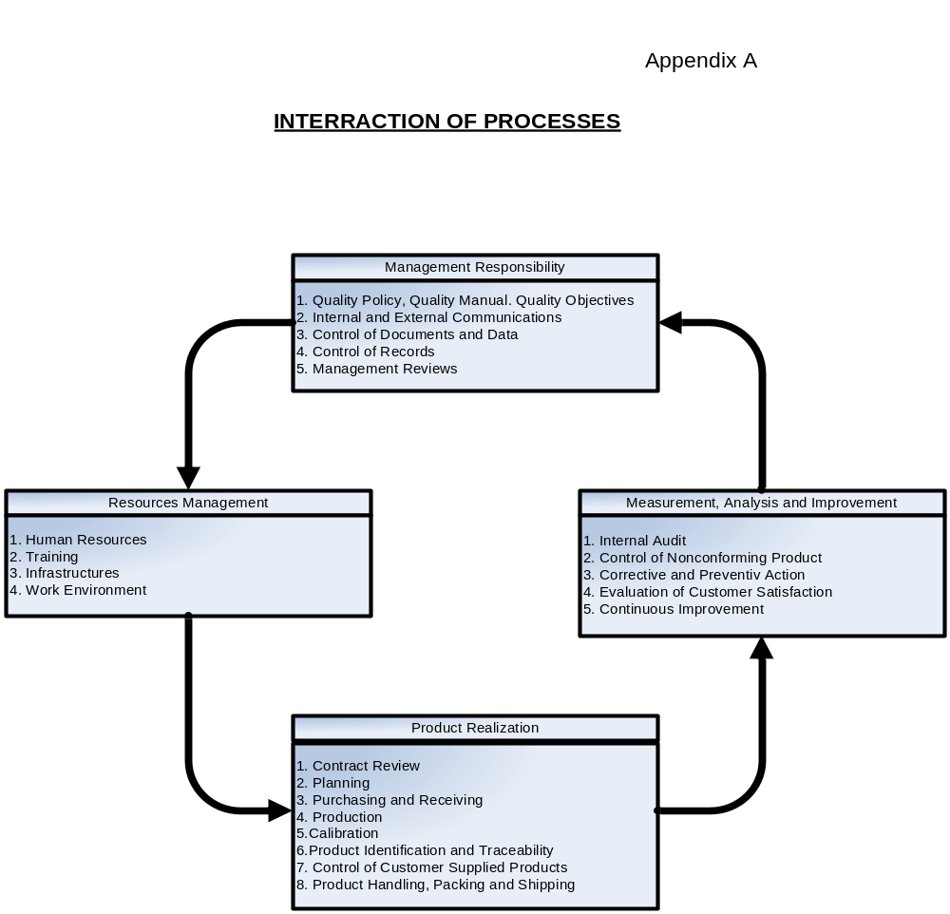
.2

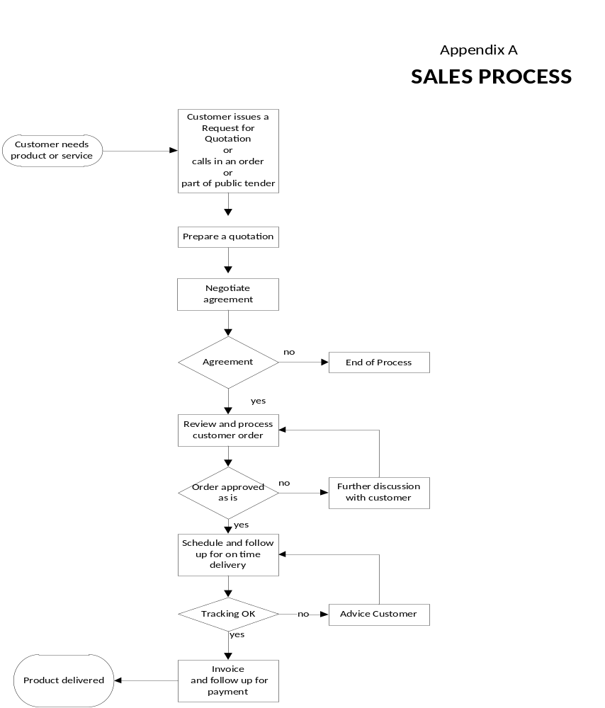
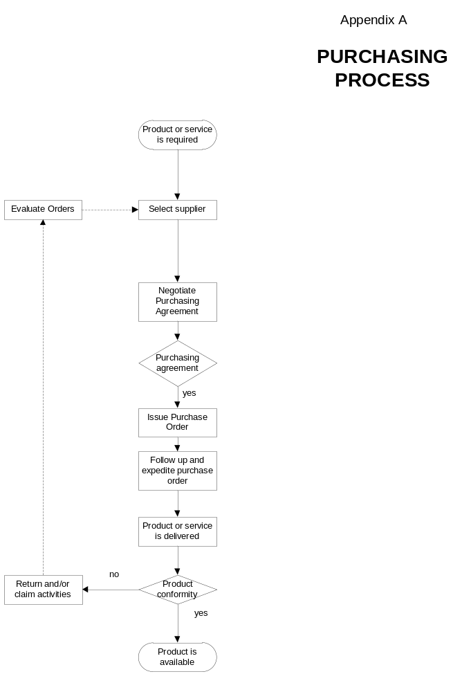

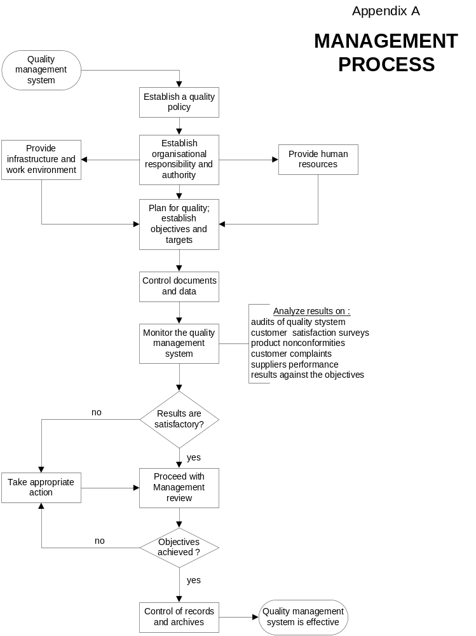

A.3 Organization Chart

